CENWP-OD-D 6/8/2022

MEMORANDUM FOR THE RECORD 22TDA09

SUBJECT: Gatewell salmonid mortality

On Jun8, while doing gatewell inspection a salmonid mortality was observed inside a cross support of a bulkhead in gatewell 9-1. It appears to have become stranded as water level receded. This is a rare occurrence in these locations. Speculation is this could be a result of recent very rapid forebay fluctuations seen daily.

- Species –appears Chinook from distance
- Origin –NA
- Length –NA
- Marks and tags –NA
- Marks and Injuries found on carcass –NA
- Cause and Time of Death – likely stranding
- Future and Preventative Measures –no changes planned at this time.

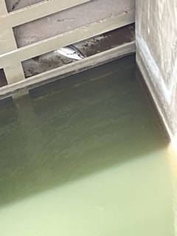

Sincerely,
Project Fisheries

